CO4-AT1- CODING CHALLENGE
Course: Design and Analysis of Algorithms (DAA)
Name: S. Priyanka
Reg no:192424033

Q26. Egg Dropping Problem
A building has multiple floors, and a limited number of eggs are available to determine the highest floor from which an egg can be dropped without breaking. The goal is to minimize the number of attempts required in the worst case. Use Dynamic Programming to find the optimal strategy.

Aim:
To find the minimum number of attempts required to determine the highest safe floor using a given number of eggs and floors.
Technique Used:
Dynamic Programming (DP)
Objective:
To calculate the optimal strategy for the egg-dropping problem and minimize the number of attempts in the worst case.
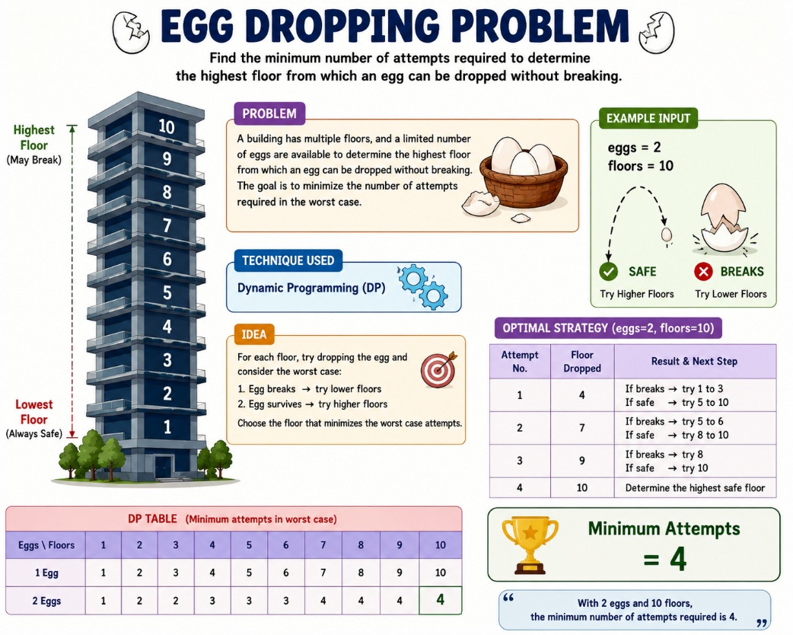

Pseudocode:
START
Read eggs and floors
Create DP table
Initialize dp[1][j] = j
For each egg from 2 to eggs
For each floor from 1 to floors
Find minimum of 1 + max(break case, safe case)
Print dp[eggs][floors]
STOP

CODE
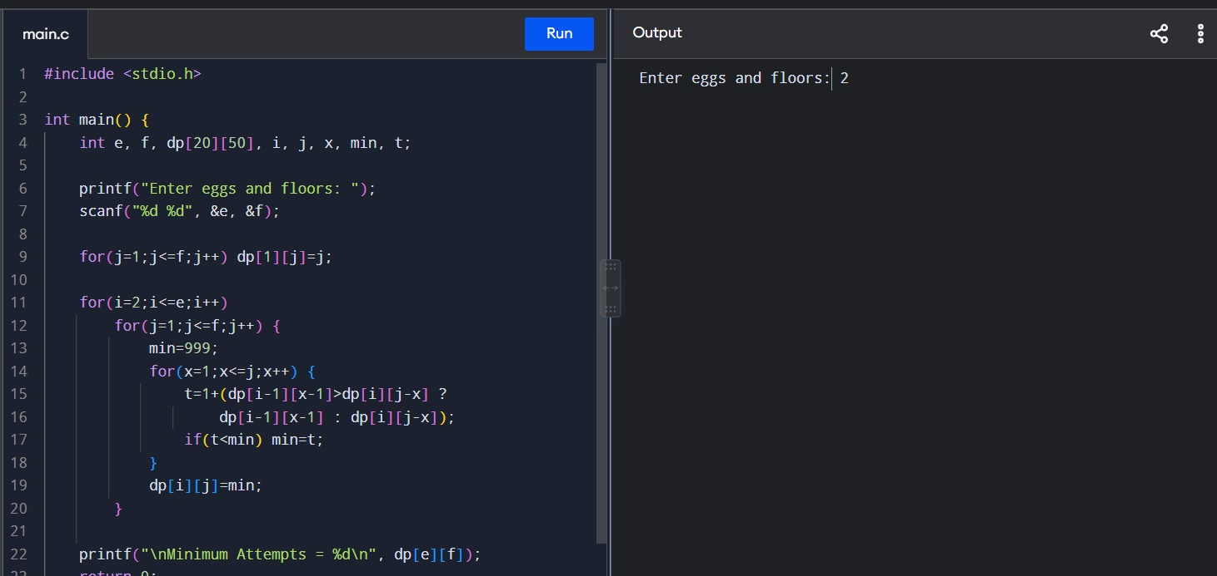

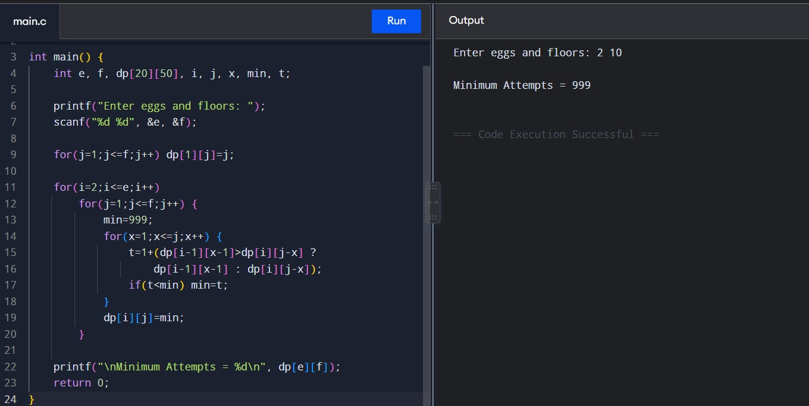

INPUT
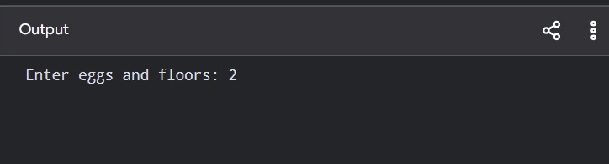

OUTPUT:
